Database project

Topic-Riva fashion database

SCENARIO-
A Company called Riva is a fashion brand expert in clothing, footgear, accessories, and scents for females, they want to make a database about the orders of their CUSTOMER - custid (as identifier), phone (a customer can have more than one number), custname. ORDER - orcode (as identifier), ordetails. PRODUCT – is identified with procode, proname.
There are some business rules: -
- A customer buys more than one product, but a product is bought by one and only one customer.
- An order contains more than one product, and a product belongs to more than one order, when a product is ordered order_date is recorded.

ERD DIAGRAM-
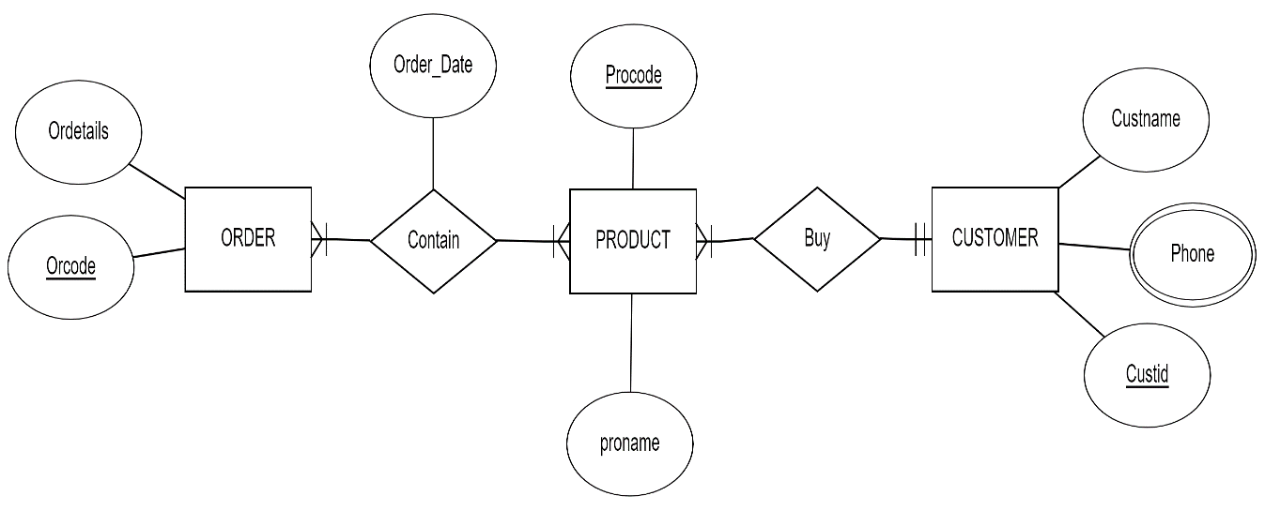
RELATIONAL SCHEMA-
- Order (orcode, ordetails)
- Product (procode, proname, custid)
- Contain (order_date, procode, ordercode)
- Customer (custname, custid)
- Cust_phone (phone, custid)
NORMALIZATION-

Procode-P120 proname-Shoes

Custid | Phone | Custname | Orcode | Ordetails | Orderdate
111 | 223344 | Nada | R20 | SC99 | 11-12-2023
112 | 223355 | Salma | R21 | DE55 | 16-12-2023
113 | 223366 | Malak | R22 | TA66 | 03-12-2023
114 | 223377 | Nasra | R23 | GJ22 | 05-12-2023

- UNF-
Custid | Phone | Custname | Orcode | Ordetails | Orderdate | Procode | Proname
111 | 223344 | Nada | R20 | SC99 | 11-12-2023 | P120 | Shoes
112 | 223355 | Salma | R21 | DE55 | 16-12-2023 | P120 | Shoes
113 | 223366 | Malak | R22 | TA66 | 03-12-2023 | P120 | Shoes
114 | 223377 | Nasra | R23 | GJ22 | 05-12-2023 | P120 | Shoes

- 1st NF-
Custid | Phone | Custname | Orcode | Ordetails | Orderdate | Procode
111 | 223344 | Nada | R20 | SC99 | 11-12-2023 | P120
112 | 223355 | Salma | R21 | DE55 | 16-12-2023 | P120
113 | 223366 | Malak | R22 | TA66 | 03-12-2023 | P120
114 | 223377 | Nasra | R23 | GJ22 | 05-12-2023 | P120

Procode | Proname
P120 | Shoes
P120 | Shoes
P120 | Shoes
P120 | Shoes

- 2nd NF-
Procode | Proname
P120 | Shoes
P120 | Shoes
P120 | Shoes
P120 | Shoes

Custid | Phone | Custname | Orcode | Ordetails
111 | 223344 | Nada | R20 | SC99
112 | 223355 | Salma | R21 | DE55
113 | 223366 | Malak | R22 | TA66
114 | 223377 | Nasra | R23 | GJ22

Orderdate | Procode | Orcode
11-12-2023 | P120 | R20
16-12-2023 | P120 | R21
03-12-2023 | P120 | R22
05-12-2023 | P120 | R23

- 3rd NF-

- Order_Product_Ordate
Orderdate | Procode | Orcode
11-12-2023 | P120 | R20
16-12-2023 | P120 | R21
03-12-2023 | P120 | R22
05-12-2023 | P120 | R23

- Product
Procode | Proname
P120 | Shoes
P120 | Shoes
P120 | Shoes
P120 | Shoes

- Order
Orcode | Ordetails | Custid
R20 | SC99 | 111
R21 | DE55 | 112
R22 | TA66 | 113
R23 | GJ22 | 114

- Customer
Custid | Phone | Custname
111 | 223344 | Nada
112 | 223355 | Salma
113 | 223366 | Malak
114 | 223377 | Nasra

SQL-
- Customer Table-
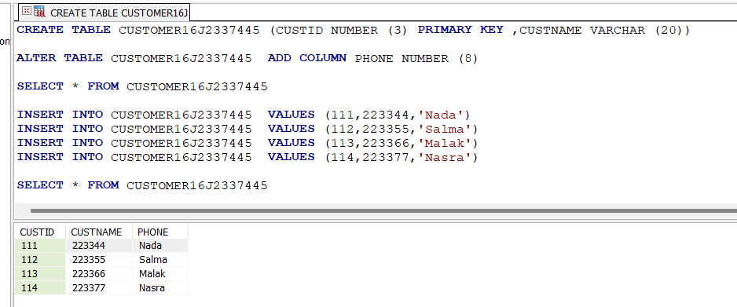
-This executed table is the result of all commands including the Alter table command
- Product Table-
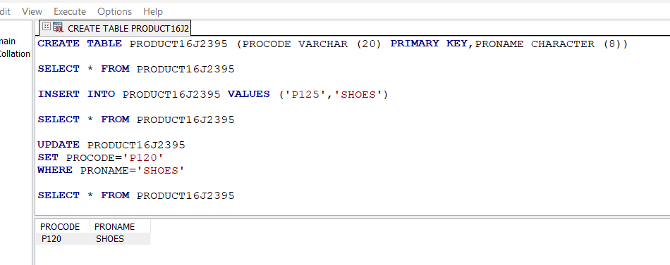
-This executed table is the result of all the commands including the update command.

- Order Table-
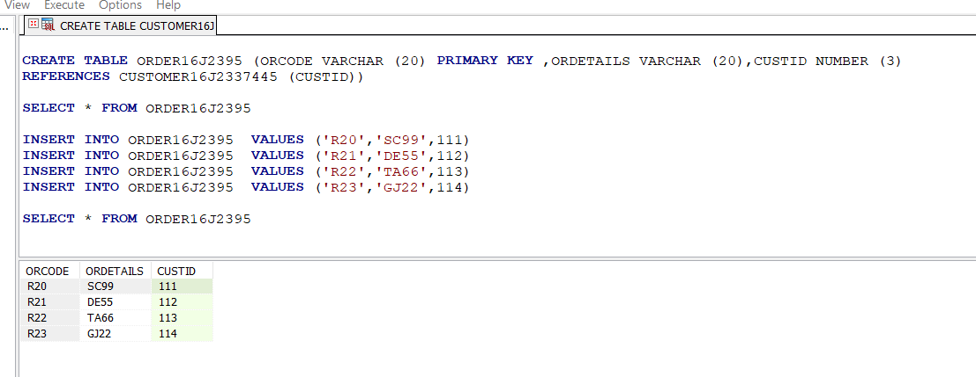
-This executed table is the result of all the commands.

